Butterfly Labeling Worksheet
Instructions:
1) Color the monarch below the way it would really look in the wild
2) Label the indicated (in red) parts of the butterfly with their anatomical names.
3) Place your initials in one of the discall cells.
4) Is this monarch male or female? How can you tell?
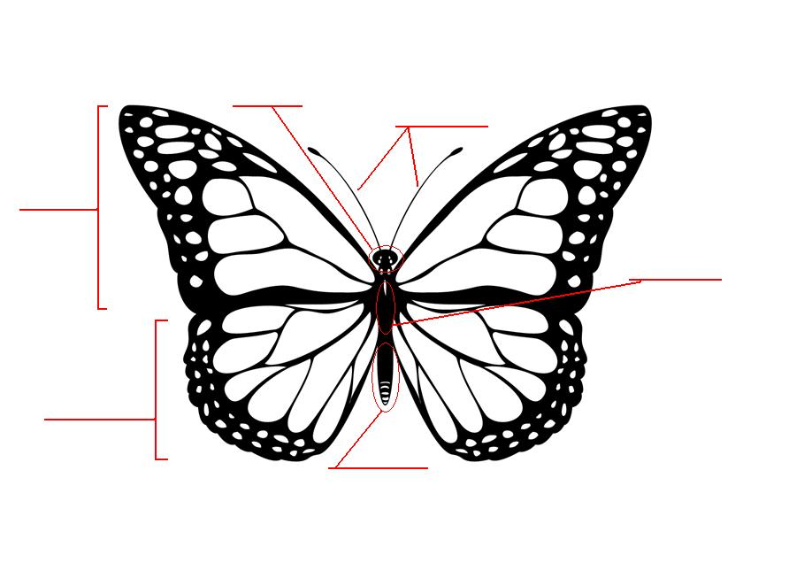
5) Draw on the butterfly to make it look like a male.

