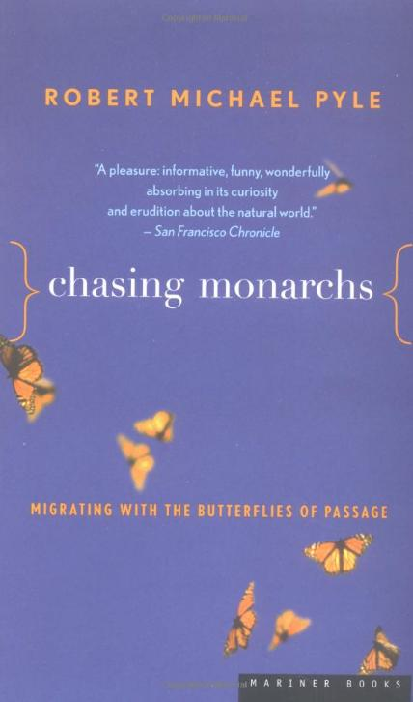
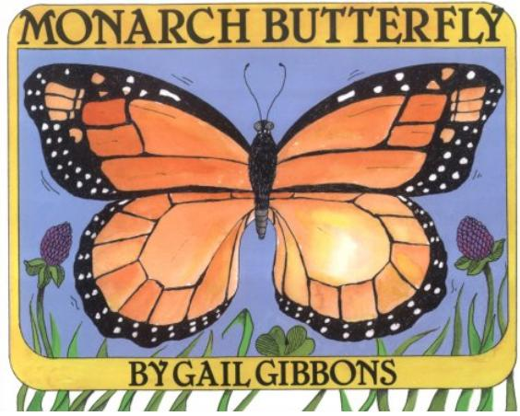
For ages 4-8; this book focuses on the monarch life cycle.

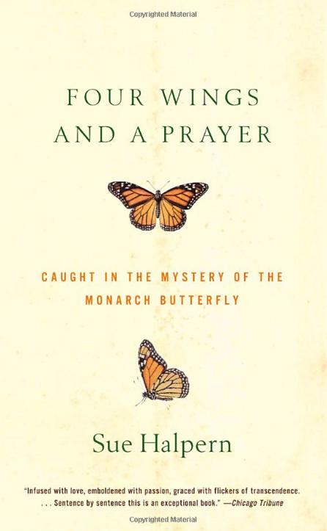
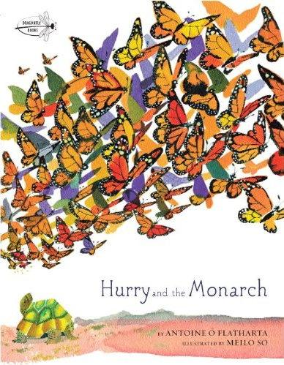
For ages 4-8; beautifully illustrated; book focuses on the monarch migration.

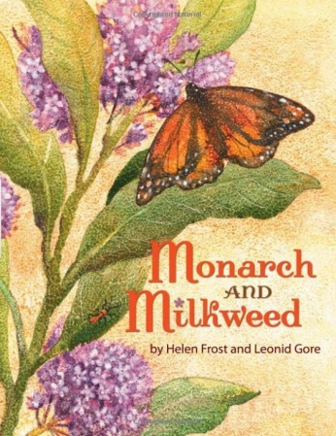
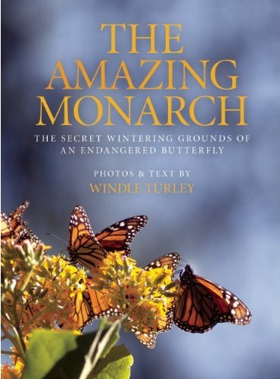
For ages 4-8; book focuses on the unique relationship between monarchs and milkweed plants.

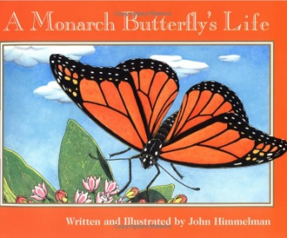
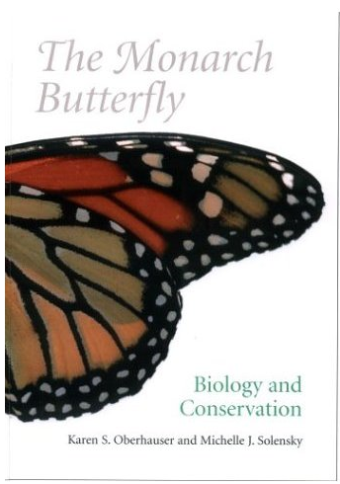
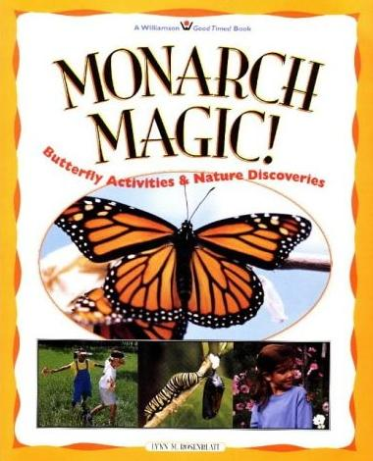
For ages 4-8; more of a storybook, but includes a foreword with misc. monarch facts

For ages 4-8; includes both monarch natural history and a wealth of activities and project ideas (eg. Rearing monarchs).

A lighthearted documentary style memoir – detailed account of the author’s experience of monarch migration; appropriate for middle/high school.

A fun and factual look at some of the science and projects surrounding the monarch migration to Mexico; appropriate for middle/high school)

More of a “text” style book which describes the life cycle, migration, and natural history of the monarch. A great teacher resource.

A complete monarch text –covers everything from anatomy to conservation; ideal for a college course or any researcher focusing on monarchs

